**Displaying Numbers on Seven Segment Display**

Aim:

A seven-segment display is a great way to display numbers with an Arduino Uno. It consists of seven LEDs (segments) arranged in a rectangular fashion to display the numbers 0-9. Each segment is identified by a letter (a to g) and is connected to a corresponding pin on the Arduino.

### Components Needed:

* Arduino Uno
* Seven-segment display (common cathode or common anode)
* Resistors (220Ω for each segment)
* Jumper wires
* Breadboard

### Wiring a Seven-Segment Display:

A seven-segment display can be of two types:

1. **Common Cathode**: All cathode pins of the LEDs are connected together to ground.
2. **Common Anode**: All anode pins are connected together to the positive supply.

For this example, I will describe wiring for a **common cathode** display.

Seven-Segment Display Pin Mapping:

|  |  |  |  |  |
| --- | --- | --- | --- | --- |
| |  | | --- | | **Segment** |  |  | | --- | |  | | |  | | --- | | **Pin Number** | |
| A | 9 |
| B | 8 |
| C | 7 |
| D | 6 |
| E | 5 |
| F | 4 |
| g | 3 |
| DP | 2 |

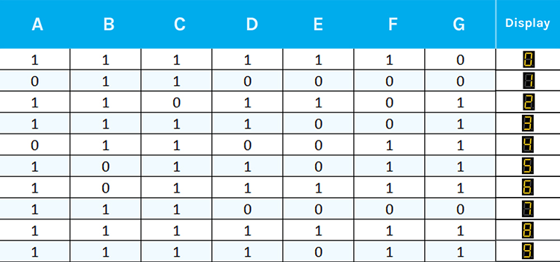

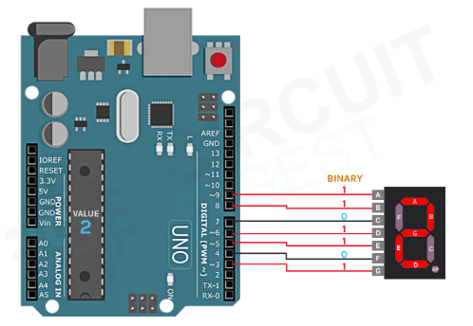

Circuit Diagram

Code:

#include "SevSeg.h"

SevSeg sevseg;

void setup()

{

//Set to 1 for single-digit display

byte numDigits = 1;

//defines common pins while using multi-digit display. Left for single digit display

byte digitPins[] = {};

//Defines Arduino pin connections in order: A, B, C, D, E, F, G, DP

byte segmentPins[] = {9,8, 7, 6, 5, 4, 3, 2};

byte displayType = COMMON_CATHODE; //Use COMMON_ANODE for Common Anode display

bool resistorsOnSegments = true; //‘false’ if resistors are connected to common pin

//Initialize sevseg object. Use COMMON_ANODE instead of COMMON_CATHODE for CA display

sevseg.begin(displayType, numDigits, digitPins, segmentPins, resistorsOnSegments);

sevseg.setBrightness(90);

}

void loop()

{

//Display numbers 0-9 with 1 seconds delay

for(int i = 0; i <= 10; i++)

{

if (i == 10)

{

i = 0;

}

sevseg.setNumber(i);

sevseg.refreshDisplay();

delay(1000);

}

}

https://circuitdigest.com/microcontroller-projects/interfacing-seven-segment-display-with-Arduino